CUSTOMER RELATIONSHIP MANAGEMENT

Welcome Page:

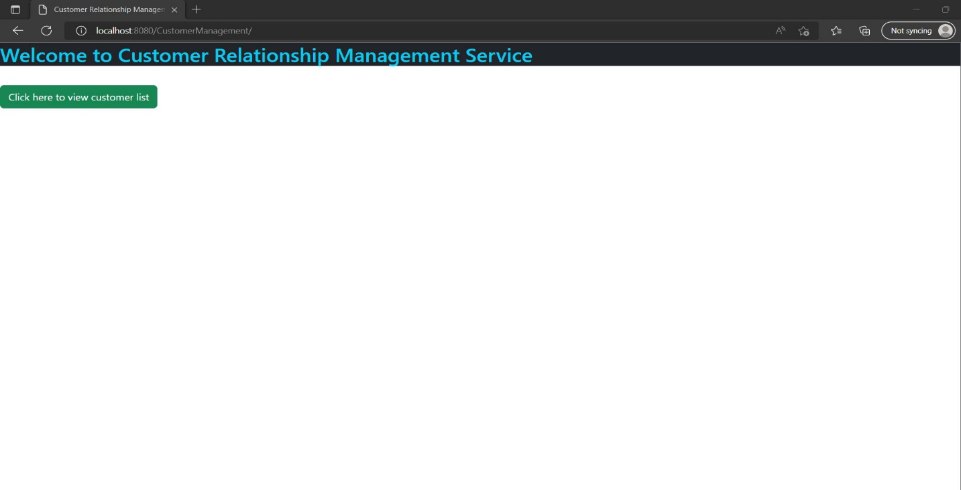

Customer List:

Customer Details:

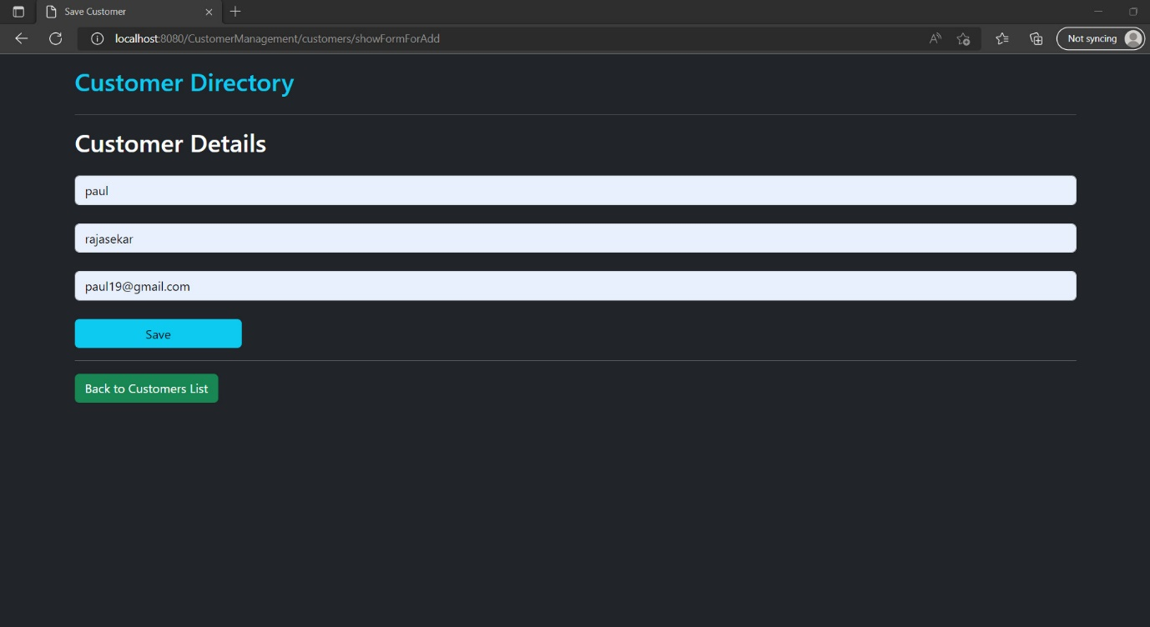

Added Customer Details :

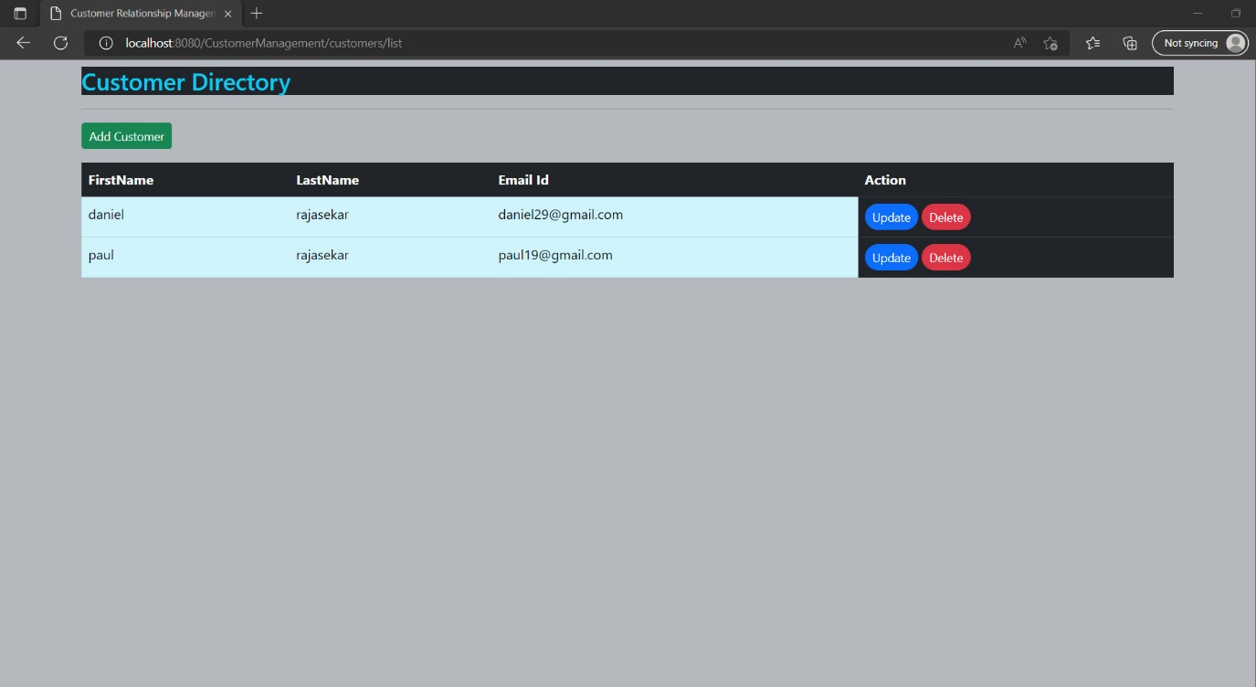

Customer Update :

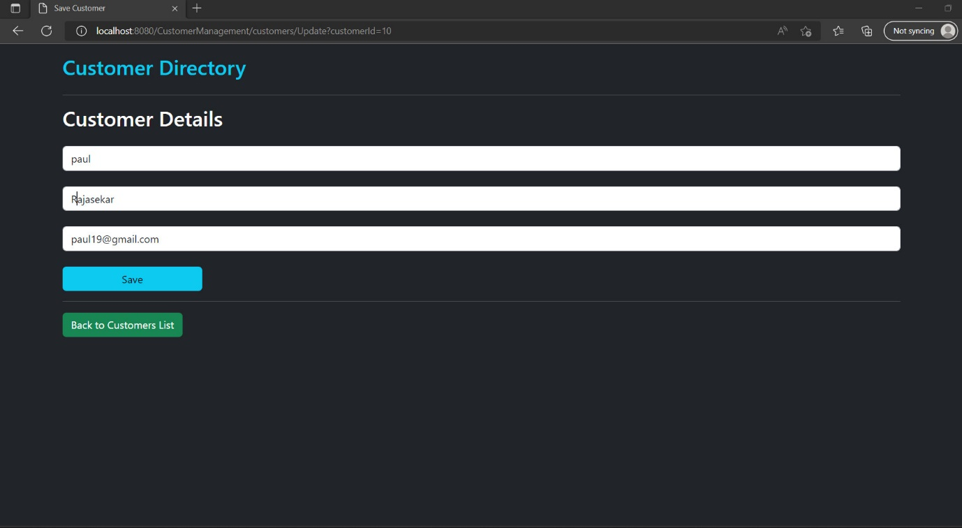

Customer Updated List :

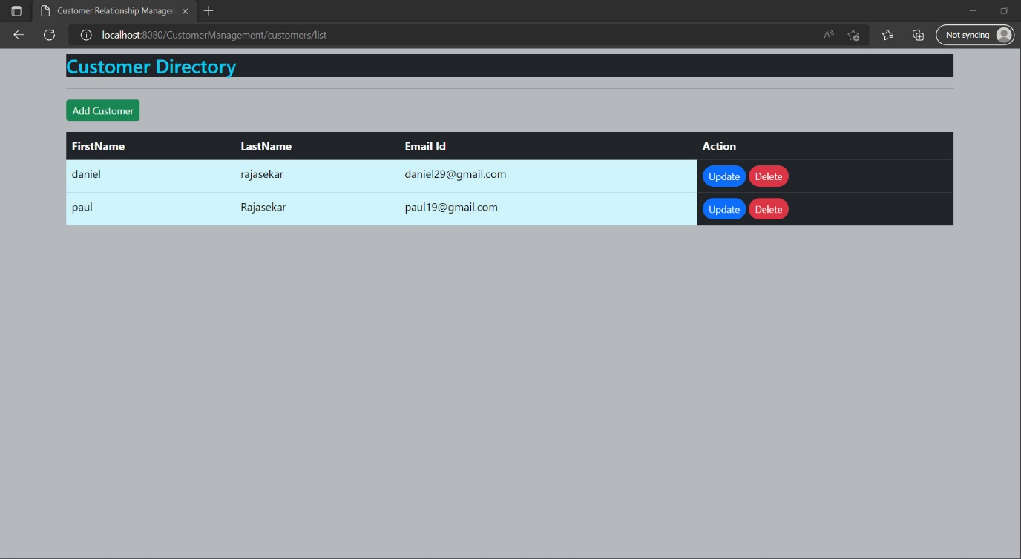

Delete Confirm Box :

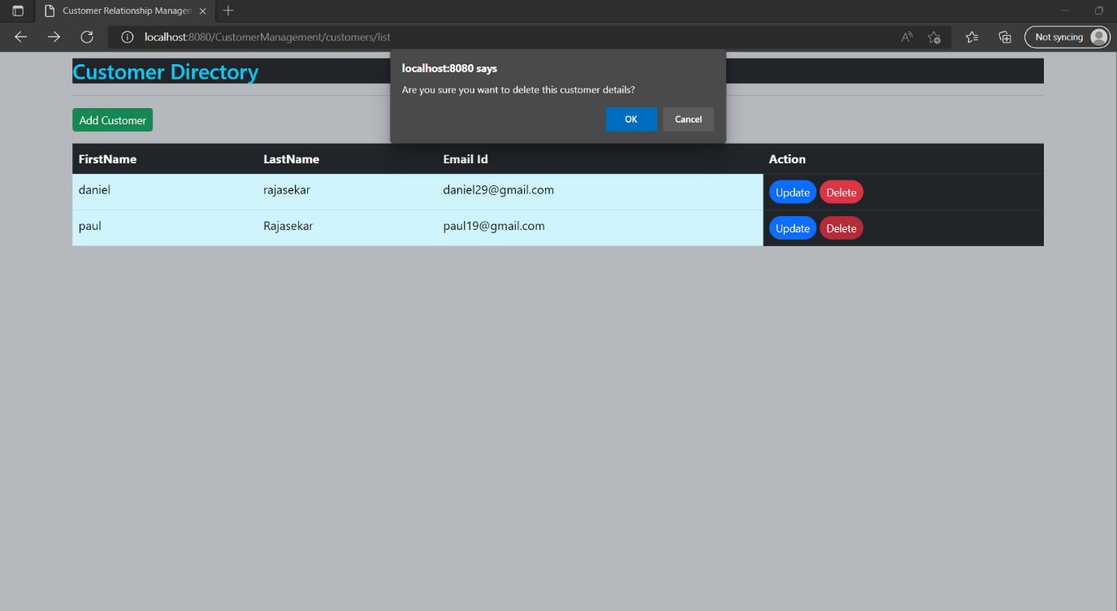

Deleted Customer List :

